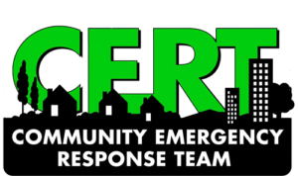
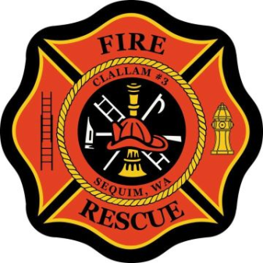
DRILL
ON THE
HILL

PREPARING THE HIGHLAND HILLS COMMUNITY FOR EMERGENCIES

Our volunteer Highland Hills Community Emergency Response Team (Bell Hill CERT) has been training and planning to minimize loss of life, rescue and treat the trapped and injured, and provide for our general welfare in the event of a major disaster. On July 12 the Bell Hill CERT held a “Drill on the Hill”. The team walked through the initial steps of our

“BELL Hill Emergency Response Plan: Outline for a Major Earthquake Scenario”

This recently updated earthquake response plan for Highland Hills can be found at the end of this article and on the HHMC Disaster Preparedness web page, http://www.hhmcsequim.org/Disaster.html .

The primary goals of this drill were to
- Test individual readiness of the CERT team
- Practice organizing at the Highland Hills CERT gathering spot
- Conduct on-site house 360's – an outside walk around assessment and mapping of a house to safely prepare for a Search and Rescue operation.

The drill also helped the team
- Practice radio communication skills and protocols
- Better appreciate the enormity of the task of responding to a major earthquake on Bell Hill
- Improve the Highland Hills earthquake response plan

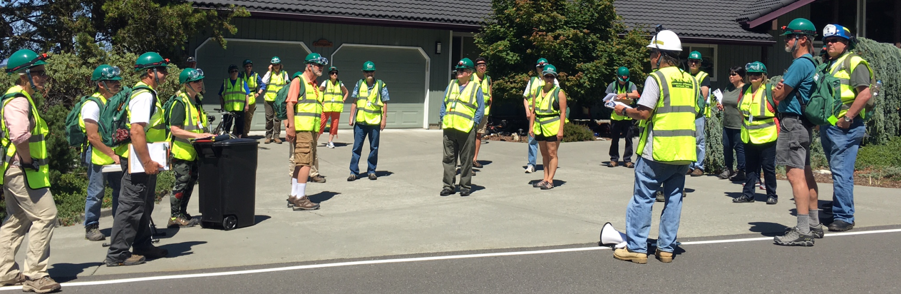
Don Baron, Bell Hill CERT Captain, Gives a Safety Briefing to the Team

The team members walking all over Highland Hills on a hot Thursday afternoon was a testament of the dedication and enthusiasm the team has for preparing our community to for emergencies.

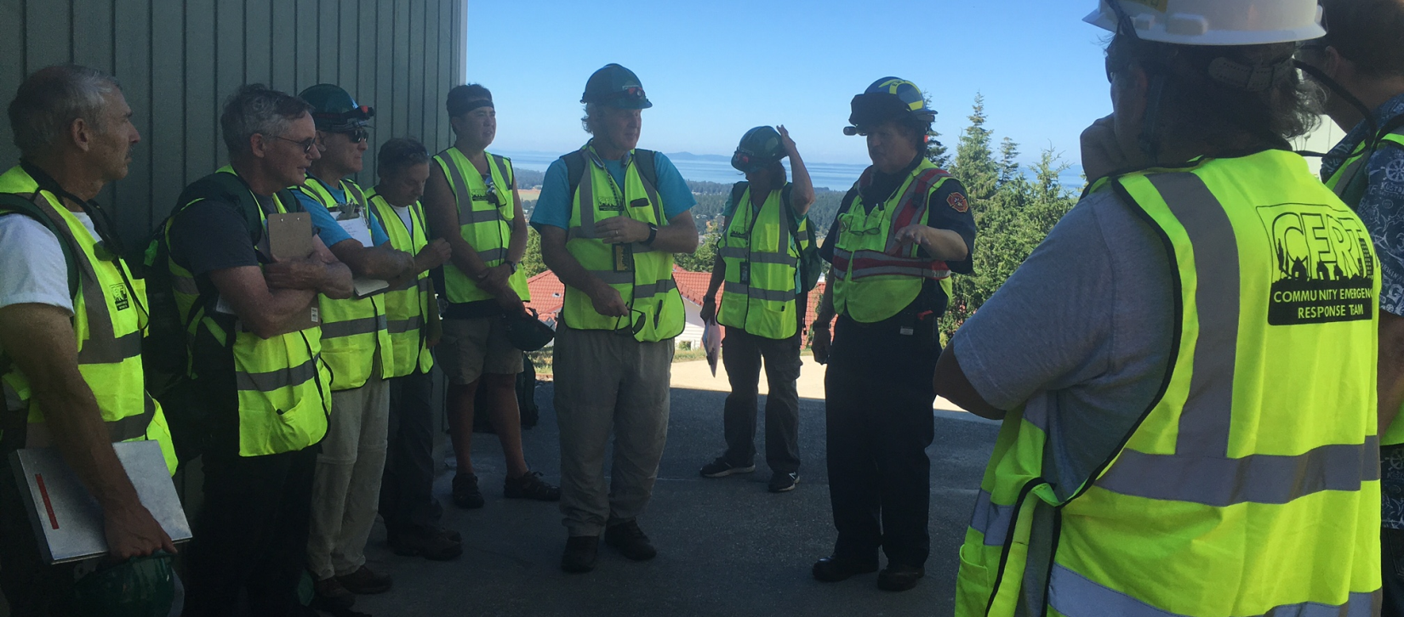
Blaine Zechenelly helps de-brief the drill.

The drill finished with a debriefing where the team went over the lessons learned. Blaine Zechenelly, who is responsible for disaster planning and an EMT for fire district 3 and Chief CERT instructor, provided some valuable feedback.

The drill helped the team realize there is trade off of doing a thorough mapping of a house to maximize the safety of the search versus a quicker rougher mapping allowing the team to enter the house sooner. The team now plans to use a pilot program to test the feasibility of advance mapping of the homes in Highland Hills to have detailed maps that allow safe and quick execution of search and rescue operations.

If you would like your home to be part of this program, please contact anyone on the CERT team including the CERT contacts listed below. It will take about 30 minutes for each house. Two team members will walk around the house producing a map which
- Shows windows and doors and identifies the best entry and exit locations.
- Locates electrical, water and propane shutoffs.
- Identifies potential hazards to a search operation.
This will map will be used speed up and safeguard a search and rescue operation in the event of a calamity at your home. The team will also be happy to answer any questions you have about emergency preparation and earthquake safety.

Please contact the Bell Hill CERT team to find out about the many ways you can help Highland Hills emergency preparedness.

HIGHLAND HILLS EMERGENCY PREPARATION CONTACTS
Don Baron, Bell Hill CERT Captain, HHMC Liaison to Emergency Management Organizations
(360) 808-2873, baronbellhill@gmail.com
Fritz Langenbacher, Bell Hill CERT Publicity and Recruiting, Alpha Search and Rescue Squad Leader
(858) 692-2971, fritz@fritzjoyce.net

BELL Hill Emergency Response Plan: Outline for a Major Earthquake Scenario v9 page 1

In the event of an earthquake, the following is a Highland Hills-specific, three-level response plan -
Plan Level 1 household/personal, Plan Level 2 neighborhood/MYN, Plan Level 3 community/CERT):

First Level - Initial Response - Personal Household Response
When the shaking starts
- Drop to a stable position, crawl to nearest pre-determined safe place (under table, desk, etc)
- Duck, cover and hold on to something, protecting head and neck
When the shaking stops
- Retrieve Earthquake Emergency Supply Bag –
  - Protective clothing, flashlight, 1st aid kit, radio, emergency response plan, …
- Put on shoes and necessary protective clothing
- Go to pre-determined outside safe location
- Determine condition of all occupants
- Provide required first aid
- Call neighborhood block leader for required help – cell phone or FRS radio
- Confirm house structural integrity before re-entering
- Review emergency plan with household members
- Post OK or HELP NEEDED sign for 1st responders
- Secure the power, propane and water systems in your home
- Put your fire extinguisher out front so it will be accessible in case the house becomes unsafe
- Establish two-bucket, personal waste system

Second Level – Neighborhood Response – Map Your Neighborhood (MYN) plan
ASAP, if your neighborhood has a designated FRS radio frequency, monitor it
- MYN 7 uses FRS channel 7 00
- don’t use FRS 5 00 for MYN communication except to report status to CERT
When the initial household response plan allows movement to the second level
- Report to your neighborhood gathering area / MYN block leader
  - note condition of homes along the way
- Formulate and Review with neighbors a day specific Neighborhood Emergency Plan
- Form teams to
  - provide first aid and manage care of the injured
  - manage communications and status reports
  - check on homes with HELP cards and those with no status posted
  - check on elderly, disabled, children and pets
  - manage necessary utility shut offs
- Radio Neighborhood status to CERT (use FRS channel 5 00 to report to CERT)
- CERT members report to CERT gathering area, noting community status along the way
BELL Hill Emergency Response Plan: Outline for a Major Earthquake Scenario v9 page 2

Third Level – Community Response – Community Emergency Response Team
ASAP – CERT members monitor CERT designated FRS frequency (FRS channel 5 00)
As soon as household and neighborhood (MYN) responses are under control, CERT members to move to the third level:
    - CERT members report to gathering area, John and Cindy Corrigan’s House, 142 Owls Nest Rd
or remote SAR squad gathering area (Alpha 222 Quails Roost, Bravo corner Doe Run and Fawn)
    - Remote SAR squads radio status to CERT Center
    - Form teams to:
      - Manage communications, status reports, and overall activity (CERT 5 Center)
      - Search and Rescue homes (SAR squads Alpha, Bravo and Charlie)
      - Provide first aid and manage care of the injured (Medical Squad Mike)
      - Provide Support (Support Squad Sierra)
    - Formulate/Review the day’s specific CERT plan
    - Prioritize operations based on neighborhood and other reports
    - Review safety precautions before deploying teams
Team Operations
    - Communications and Status Team Operations (CERT 5 Center)
      - Monitor/Supervise Medical, Search and Rescue, and Support Squad Activities
      - Contact/Monitor County Incident Command Center (ICS)
        - Report Critical Needs
        - Report CERT 5 Status
        - Get ICS status report
      - Monitor Public Radio for Status Reports
        - Road Closures
        - Utilities Status
        - Emergency Services Status
        - Emergency Alerts
        - Weather Reports
      - Maintain Activity Logs
      - Manage Walk Up Volunteers
          - Evaluate what can be done by walk up volunteers
          - Assign tasks to walk up volunteers
            - Check road conditions
            - Gather and distribute supplies
            - Clear roads
            - Support communications (message runners, monitor radios)
            - Direct incoming emergency vehicles
            - Walk the neighborhood noting problems
            - Care for Injured, Elderly, Children and Pets
BELL Hill Emergency Response Plan: Outline for a Major Earthquake Scenario v9 page 3

    - Search and Rescue (SAR) Operations
      - Formulate/Review Search and Rescue Plan of the day and safety precautions
      - SAR Logistics
        - Inventory/Gather SAR Squad Supplies and Equipment
        - Determine best way to travel to priority sites
      - Begin Search and Rescue
      - Monitor Status Reports
      - Update Priorities as reports come in
      - Maintain logs

    - Medical Care Operations
      - Designate Treatment Area(s)
      - Inventory Medical Supplies and Equipment
      - Treat the Injured
      - Call for advanced care as needed
      - Prioritize needs for advanced care
      - Maintain Logs

    - Support Squad Operations
      - Formulate/Review day specific Support Squad plan
      - Transport Injured to Treatment Areas
      - Manage overall CERT 5 Logistics
        - Assess transportation options
          - Determine passable roads
          - Determine best means to transport victims and supplies
          - Prioritize road clearing / repairs
          - Manage available vehicles
        - Manage Emergency Supplies
          - Inventory all supplies
          - Gather additional supplies as needed
          - Distribute supplies to where they are needed
      - Request/manage volunteers organized by CERT Center

